CMGT 235 – Electrical and Mechanical Systems
Department of Construction Management California State University, Chico
Exam #2 [100 points]
You may work together as a group or individually. Every student SHALL complete their own answer sheet.
All problems refer to the California Plumbing Code 2016 [Unless Noted Otherwise]
Name: ____________________________________________________________________________________
Solution

30 pts  10 pts  6 pts  6 pts  8 pts  10 pts  10 pts  6 pts  4 pts  2 pts  2 pts  2 pts  2 pts  2 pts | - Determine the Meter and Street Service size and the Building Supply size for the Dwelling shown on the next page. MDSSPA = 80 psi. The highest water outlet in the building is 9 feet above the source of supply. Pressure loss due to the meter is 5 psi and the water softener has a pressure loss of 9 psi. The maximum length of the piping between the source of supply and the furthest fixture is 208 feet. Each side of the house has a ½" hose bibb (TWO HBs PER SUPPLY SEGMENT).  Step 1. Calculate the Available Water Pressure  Available Pressure = 80 psi – 0.433 psi/ft x 9 ft – 5 psi – 9 psi = 62 psi  Step 2. Find the Effective Maximum Developed Length (DL) of Pipe  DL = 208 ft x 1.5 = 312 ft  Step 3. Calculate the total WSFU [Table 610.3]  QTY FIXTURE WSFU TOTAL WSFU  6 WC 2.5 15.0  6 LAV 1.0 6.0  1 BT 4.0 4.0  3 SHW 2.0 6.0  2 KS 1.5 3.0  2 DW 1.5 3.0  3 BS 1.0 3.0  1 SS 1.5 1.5  1 LS 1.5 1.5  1 CW 4.0 4.0  4 HB 2.5 + 1.0 x2 7.0  TOTAL WSFU 54.0  Step 4. Use the 2016 CPC Table 610.4 complete the table below for your results:  Pressure Range Over 60 psi  Maximum Allowable Length 400 ft  Distribution Piping Pipe Size (inches)  Meter and Street Service 1"  Building Supply 1 ½ "  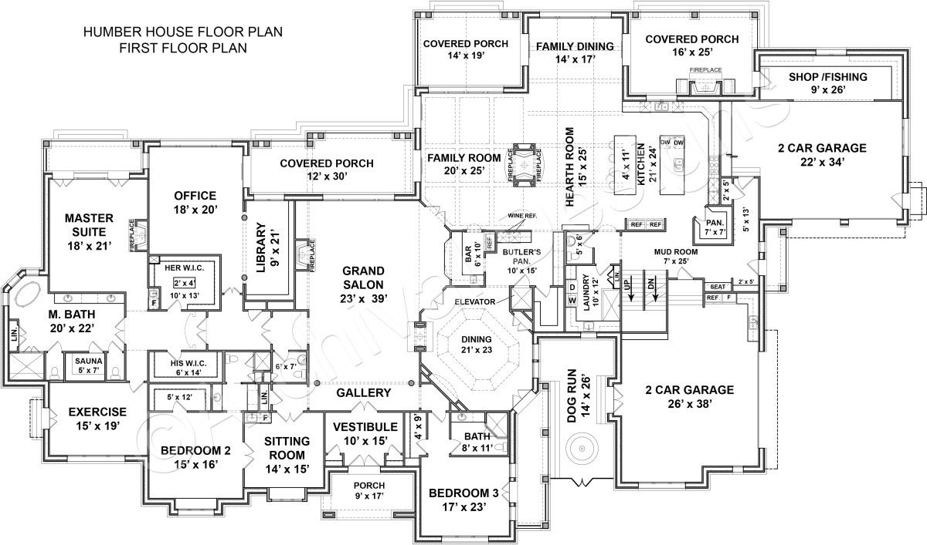  - A local restaurant has an occupancy of 250 people.  - Using the CPC 2016 complete the table for the required number of fixtures per person.  Use 50 / 50 male / female  Water Closets Urinals Lavatories Bathtubs or Showers Drinking Fountains  Male Female Male Male Female 0 1  2 4 1 1 1  - Where is the CPC 2016 did you find the requirements?  422.0 Maximum Number of Required Fixtures  TABLE 422.1  - What other fixtures are required?  1 Service Sink or Laundry Tub  Hand-washing facilities shall be available in the kitchen  - The cold-water piping for a public female restroom is shown below. The water closets have flushometer valves.  - What table is applicable to determining the WSFUs?  610.10  - Determine the total WSFU for the cold-water load.  149.0  WC  WC  WC  WC  WC  WC  WC  WC  LAV  LAV  LAV  LAV  4.0  1.0  1.0  1.0  1.0  +10.0 +10.0 +10.0 115.0  10  15  20  30  40  Total WSFU = 4.0 + 115.0 + 30.0 = 149.0  - For a public rest room what are the required ADA requirements for:  - Water closet height  17" - 19" to top of toilet AFF  - Water closet flush control  No more than 44" from mounting surface  - Determine the total DFU for the 8 public flushometer toilets and 6 lavatories. What size vent is required for the total DFU and what is the maximum length the vent can be?  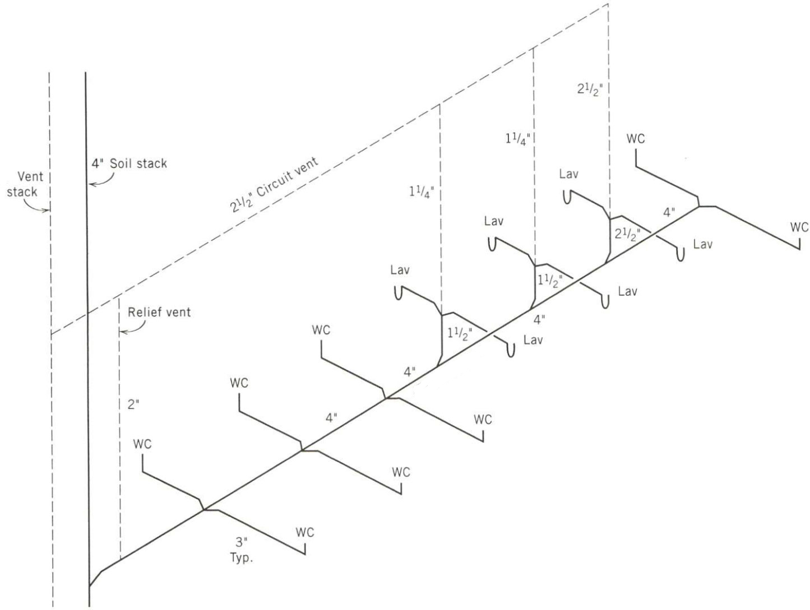  38.0 DFU  4.0  4.0  4.0  4.0  4.0  4.0  4.0  1.0  1.0  1.0  1.0  1.0  1.0  4.0  Total = 38 DFU  3" vent required  212 ft maximum length  - For the basic home shown complete the Hot, Cold, and Combines WSFU table shown below.  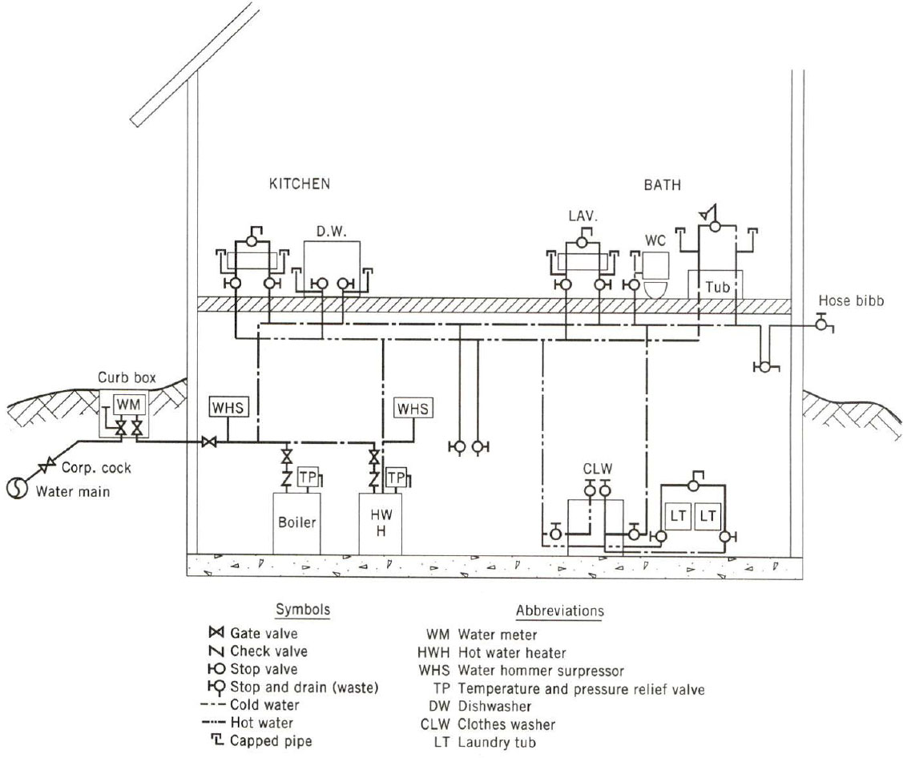  Water Supply Fixture Units  Fixture # of Fix. HOT WSFU COLD WSFU TOTAL WSFU  EACH THIS JOB EACH THIS JOB EACH THIS JOB  WC 1 --- --- 2.5 2.5 2.5 2.5  LAV 1 0.75 0.75 0.75 0.75 1.0 1.0  BT/SHW 1 3.0 3.0 3.0 3.0 4.0 4.0  LT 1 1.125 1.125 1.125 1.125 1.5 1.5  CW 1 3.0 3.0 3.0 3.0 4.0 4.0  KS 1 1.125 1.125 1.125 1.125 1.5 1.5  DW 1 1.125 1.125 1.125 1.125 1.5 1.5  HB 1 --- --- 2.5 _ 1.0 3.5 3.5 3.5  TOTALS 10.125 16.125 19.5  13.75  G1=18 d1=13 d=13 + (19.5-18)/(20-18) x (14-13)  G2=20 d2=14 d=13.75 gpm  TOTAL GPM _____________________  - Determine the total DFU for the private residence shown.  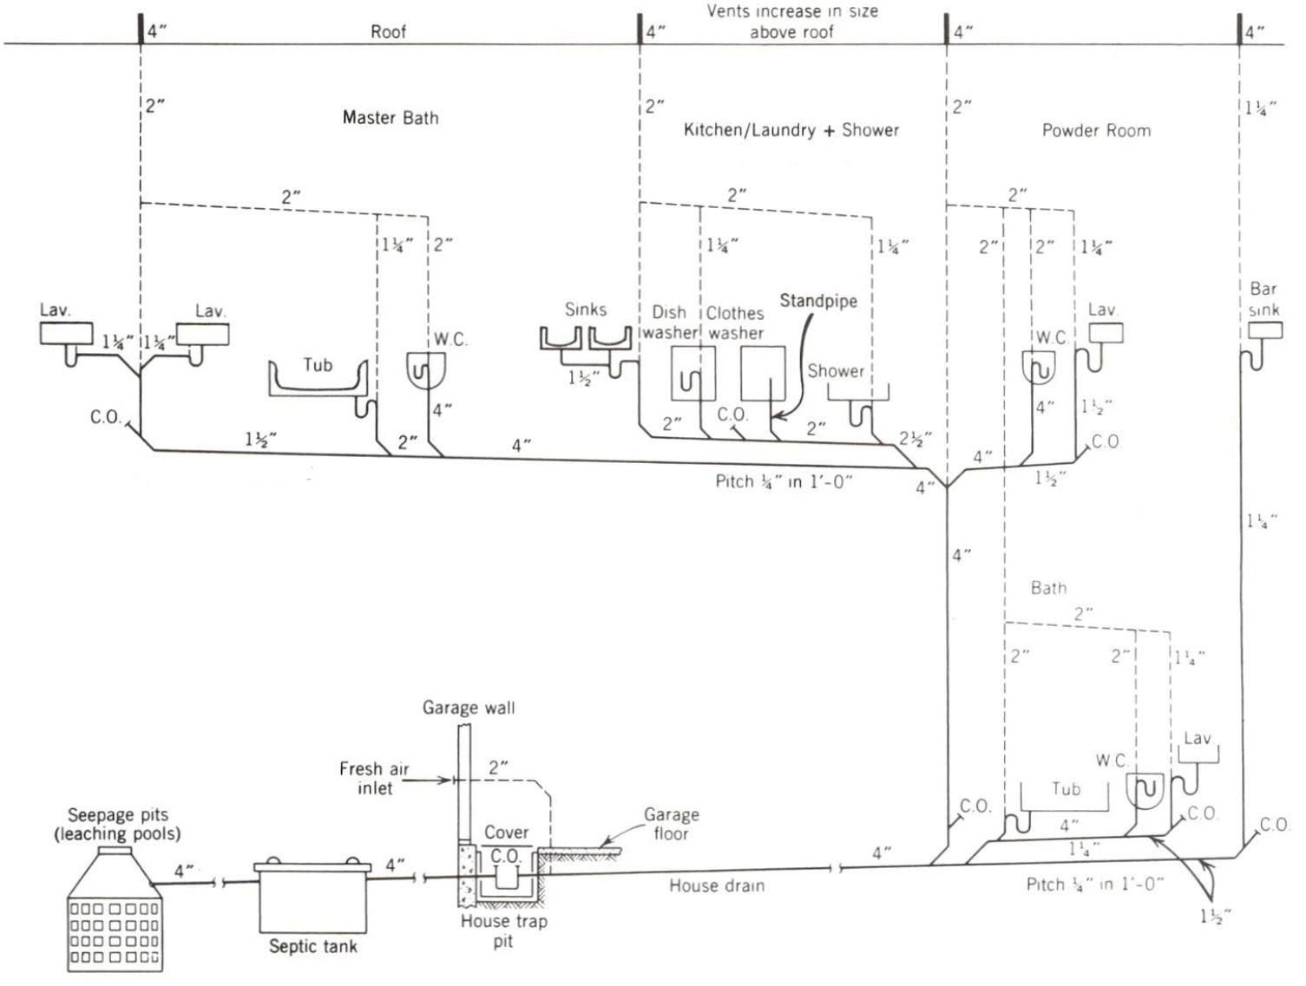  20.0  16.0  7.0  27.0  2.0  3.0  1.0  1.0  1.0  3.0  2.0  3.0  2.0  2.0  3.0  2.0  1.0  1.0  Total = 27.0 DFU  - The problem of accommodating thermal expansion of piping is particularly important for hot water and steam piping. Amount of expansion depends on:  - Type of piping used  - Temperature change  Linear expansion of a pipe is given by the equation: ∆L = C x L x ∆T  Where,  C = Expansion Coefficient  L = length of pipe  ∆T = temperature differential  Expansion Coefficients (C)  Material 10⁻⁶ in/in °F  Aluminum 12.8  Steel 6.5  Cast Iron 5.9  Copper 9.3  Stainless Steel 9.9  ABS Acrylonitrile butadiene styrene 35.0  HDPE High density polyethylene 67.0  PE Polyethylene 83.0  CPVC Chlorinated polyvinyl chloride 44.0  PVC Polyvinyl chloride 28.0  In a school building the distance between the hot water boiler and the cafeteria dishwasher is 175 ft. What is the increase in length of the hot water piping from a “resting” condition (shutdown) of 55⁰F to an operating condition carrying 140⁰F water using  (a) copper pipe?  ∆L = C x L x ∆T = 9.3 x 10⁻⁶ in. / in ⁰F x 175 ft x (140⁰F - 55⁰F) = 1.66 in.  (b) CPVC plastic pipe?  ∆L = C x L x ∆T = 44 x 10⁻⁶ in. / in ⁰F x 175 ft x (140⁰F - 55⁰F) = 7.85 in.  - Determine the horizontal and vertical drainage pipe size for 5,000 square feet of roof area (1/8” slope per 12” of pipe) on a building located in Dallas, TX.  From Appendix D (2016 CPC) Dallas, TX has a rainfall rate of 4.2 inch per hour. However, the local code specifies that sizes of storm drains shall be based on a 6 inch per hour rainfall rate.  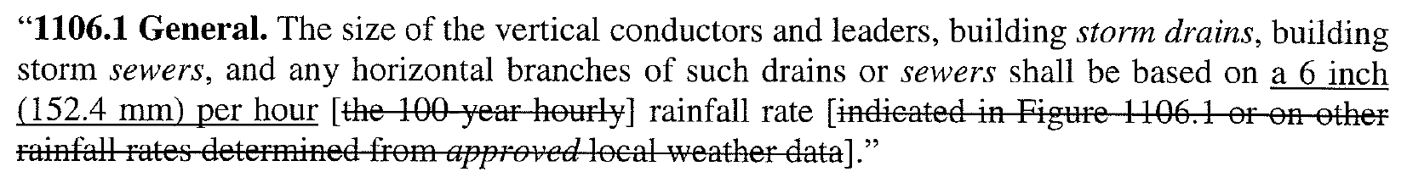  Table 1101.8 – Sizing of Horizontal Rainwater Piping  1/8” per 12” of pipe slope, 5000 square feet of roof area  Required pipe size is 8 inches  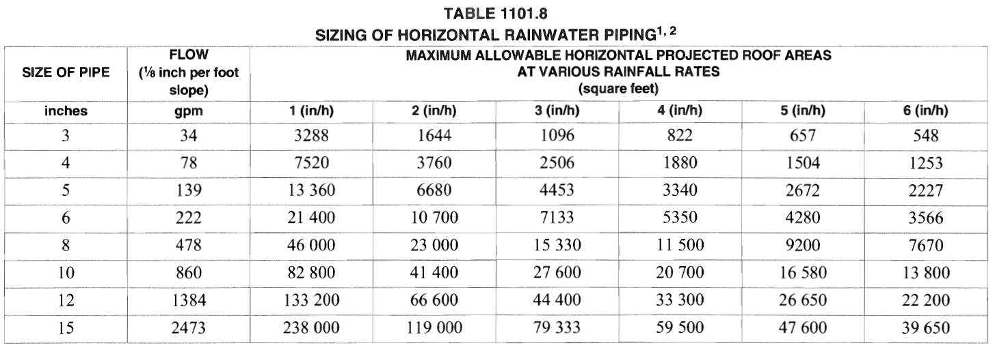  Table 1101.12 Sizing Roof Drains, Leaders, and Vertical Rainwater Piping  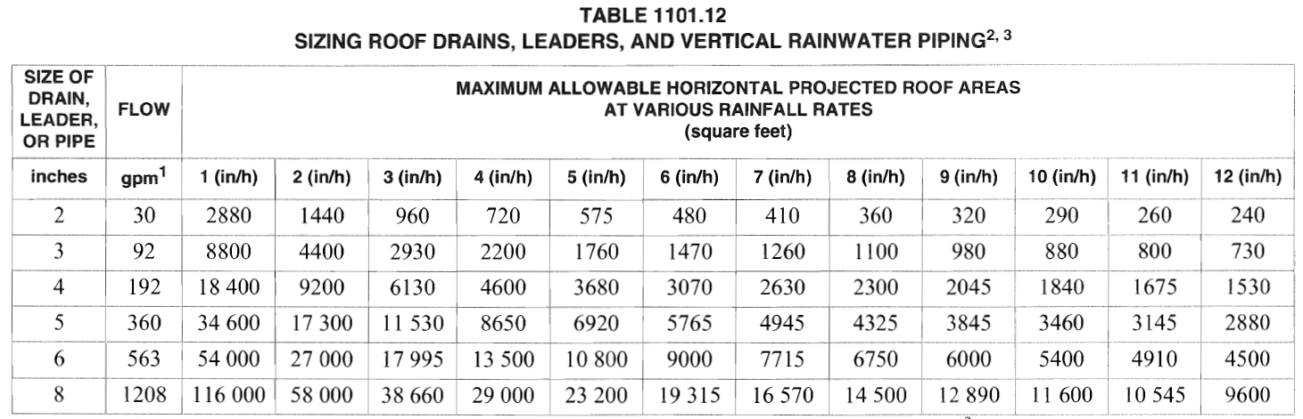  Minimum leader size is 5 inches.  However, from the Texas Plumbing Code  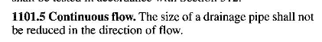  Vertical pipe must be 8 inches  - For a 4-inch horizontal storm drain, what is the maximum projected roof area if the slope of the drain is ¼-inch per 1 ft of pipe? What table is used to find the answer?  Table 1101.8  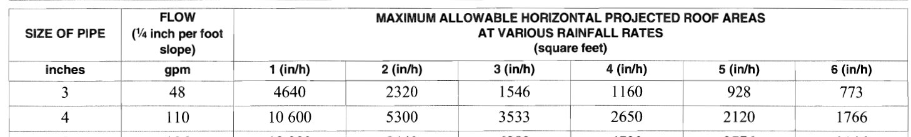  - Determine the number of 5” roof drains required for a roof area of 230,000 sq. ft located in Denver, Colorado.  Denver Amended Plumbing Code  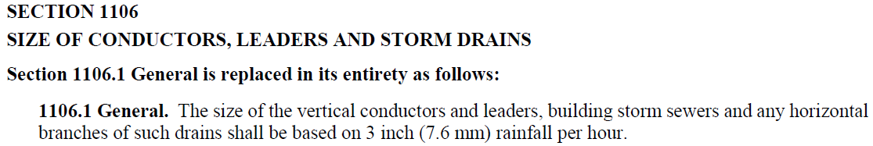  No. of Drains = 230,000 / 11,530 = 19.95 = 20 roof drains  From Appendix D = Table D 101.1  Denver, Colorado – 2.2 inches per hour rainfall rate  No. of Drains = 230,000 / (34,600/2.2) = 14.6 = 15 roof drains  - What is BMP an acronym for?  Best Management Practice  - What federal act was passed in 1972 to regulate the discharge of pollutants to receiving waters such as oceans, bays, rivers, and lakes?  Clean Water Act (CWA)  - What is a system that conveys both sewage and stormwater to sewage treatment plants before the treated effluent is discharged to receiving water bodies called?  Combined sewer system

