|  |  |  |
| --- | --- | --- |
| **CMGT 235 – Electrical and Mechanical Systems** | | |
| **Discussion No. 23** | **Unit 3 - Electrical Systems** | **Fall 2019** |

**Voltage Drop**

**Example #5 - Temporary Job Site Light, Tripod, Corded (AC), Lumens 8000, Number of Lamp Heads 1**

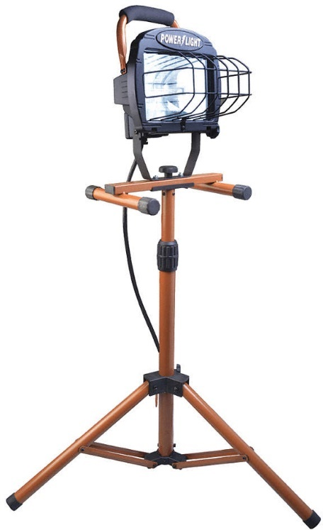

|  |  |  |
| --- | --- | --- |
| **Gauge/Conductor** | **Ohms/kFT** | **Length (L) ft** |
| 18/3 |  |  |
| 16/3 |  |  |
| 14/3 |  |  |
| 12/3 |  |  |

**Example #6**

A single-phase, 240-volt air-conditioner is being installed for a small commercial building. The nameplate reads: “Minimum Circuit Ampacity 40 Amperes.” The circuit originates at the main panel located 125 ft from the air-conditioner unit.

1. Determine the maximum voltage drop of the line recommended by the NEC?
2. What is the minimum size THWN CU conductors required and where in the NEC do you find this?
3. Determine the voltage drop due to the conductors. Does it meet the code requirement? If not, what should be done to meet the code?