|  |  |  |
| --- | --- | --- |
| **CMGT 235 – Electrical and Mechanical Systems** | | |
| **Discussion No. 25** | **Unit 3 - Electrical Systems** | **Fall 2022** |

**Commercial Building Electrical Systems – Power System**

**Building Wire and Cable**

Most commonly known as branch circuit wiring

Supplies electrical current to all external uses of power in a building or dwelling

**Branch Circuits**

The circuits that deliver electricity to the various areas of a building or home are referred to as branch circuits.

The National Electrical Code (NEC) defines a branch circuit as “the conductors between the branch circuit final overcurrent device protecting the circuit and the outlets” (such as receptacles or lights). [Article 100 Definition]

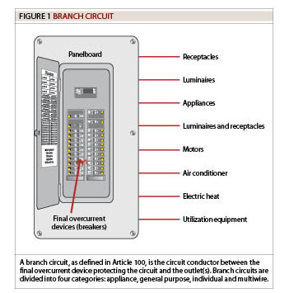

Branch circuits originate at a service distribution panel which provides either single-phase (1Ø) or 3-phase (3Ø) power at the required voltage value.

A 3Ø panel has three hot busbars and one neutral busbar.

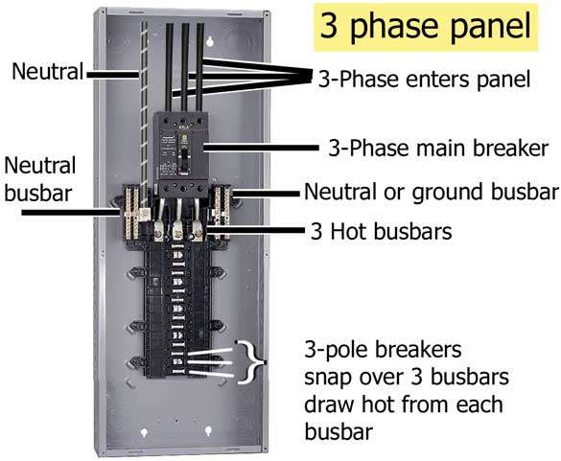 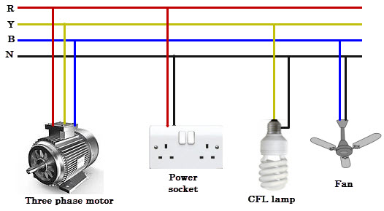

A 1Ø panel has two hot busbars and one neutral busbar.

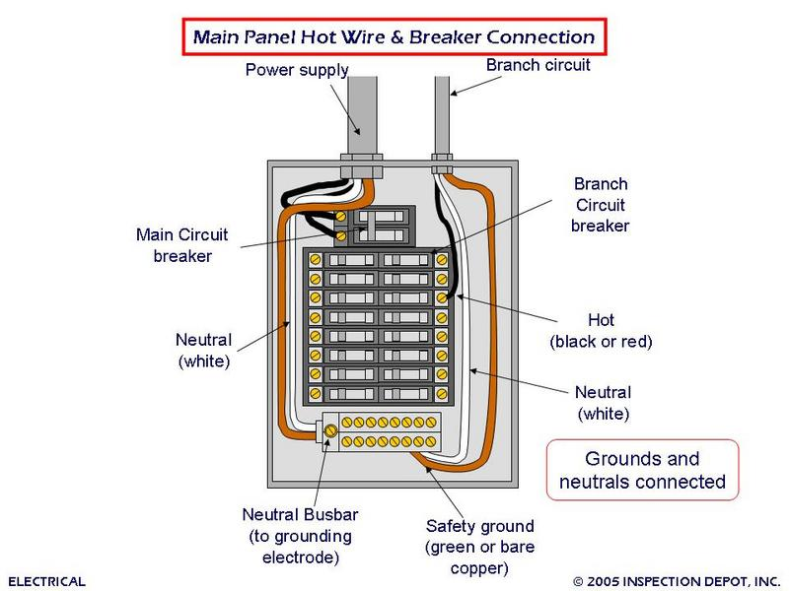

Depending on the amount of electricity a given circuit needs to deliver, it may attach to only one hot busbar and the neutral busbar or to two or three hot busbars.

In a residential load center (120/240 VAC, 1Ø Panel), a circuit that delivers 120 volts connects to one hot busbar and the neutral busbar, and a circuit that delivers 240 volts connects to both hot busbars.

The means for attachment is commonly known as a fuse or circuit breaker, and it protects the circuit from sudden surges in current.

Neutral conductors are all grounded through direct contact with the soil. Unlike the hot busbars, a neutral busbar does not have an over-current protection device so it can maintain 0 volts at all times.

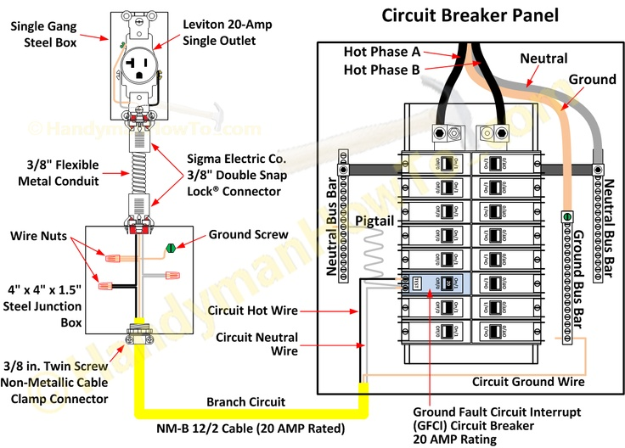

**Panel Board Schedule**

Panel board schedules are generally found on electrical drawings and are used mainly to indicate relevant information on the service-panel boards within the building.

A panel-board schedule should provide sufficient data to identify the panel number (as indicated on the drawings) and the type of cabinet (whether surface-mounted or flush). It should also provide relevant data regarding the panel main busbars and/or circuit breakers as well as the number and type of circuit breakers contained in the panel board and the components fed by each.

This type of schedule, however, does not furnish detailed information for the individual circuits (e.g., wire sizes or number of outlets on the circuit); this information needs to be shown elsewhere on the drawing, such as in the plan view or power-riser diagrams.

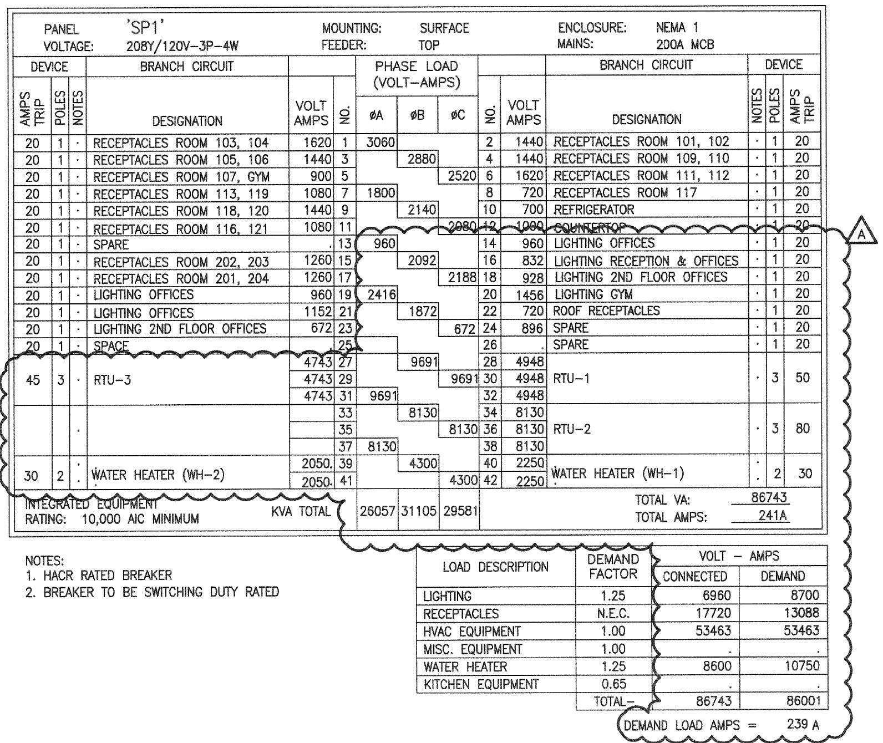

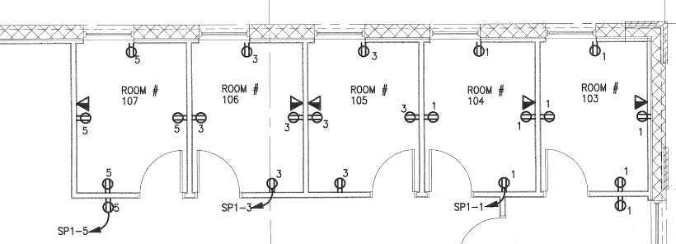

**Electrical Home Run**

An electrical home run is a wiring run that connects directly to a building's electrical panel (source).

It is usually shown on a plan using an arrow with the panel name and circuit number(s) it connects to.

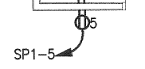

The home run shown connects to Panel SP1 – Circuit No. 5

**Raceway Fill**

Raceways must be large enough to avoid damaging the insulation when conductors are pulled into the raceway. Chapter 9 and Annex C of the NEC are the primary references for determining allowable conductor fill in raceways. For the most common condition, where multiple conductors of the same size are installed together in a raceway, the maximum number of conductors permitted can be determined from the tables in Annex C.

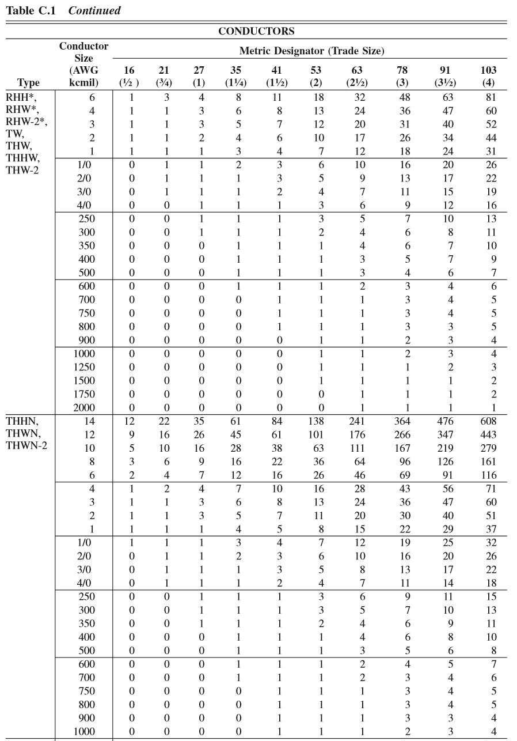

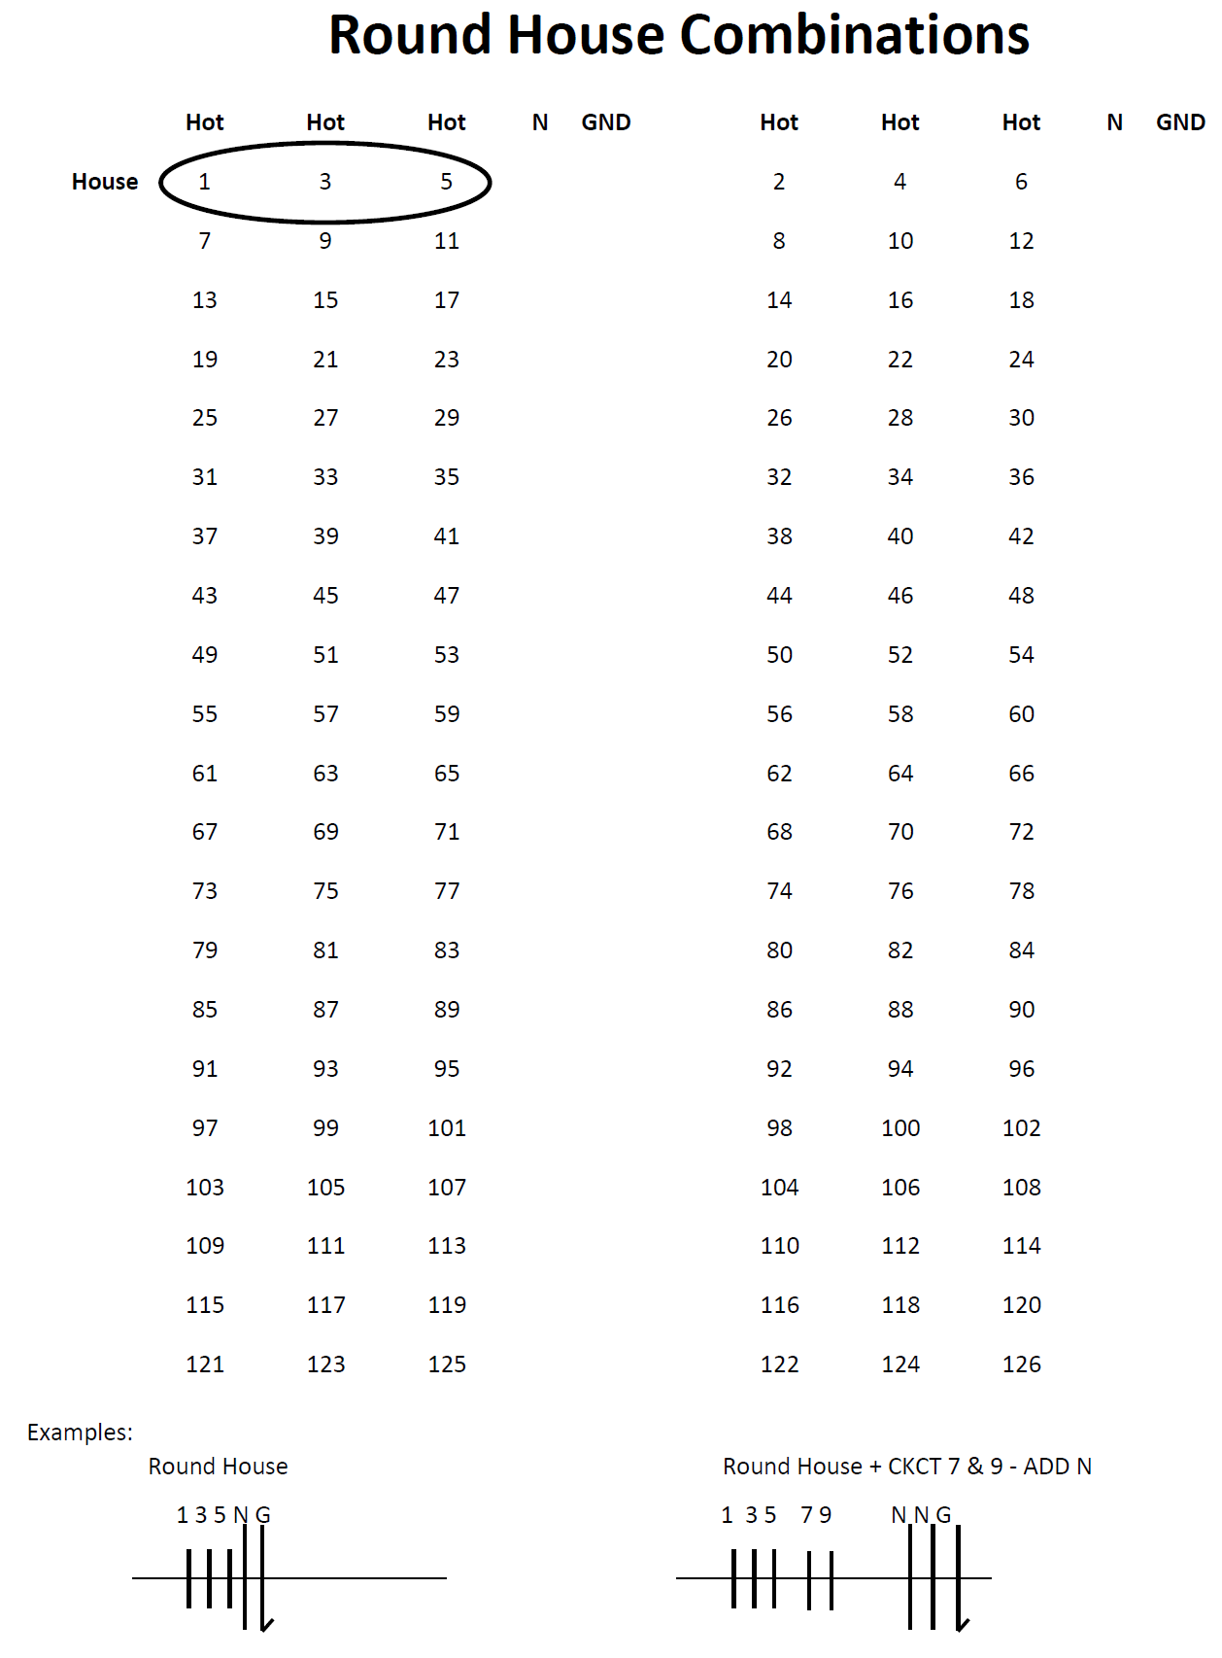

Branch Power Layout



SP1- 1, 3, 5

Branch Lighting Layout

